Table of Contents

1. Introduction 3
2. Project Overview 3
3. Objectives 4
4. Design Process 4
Requirement Analysis 4
Research 4
Wireframing 4
High-Fidelity Prototype 4
5. Design System 5
Color Palette 5
Typography 5
Icons 5
Components 6
6. Description of the Five Screens 6
Screen 1 – Home Screen 6
Screen 2 – Product Details Screen 6
Screen 3 – Shopping Cart Screen 7
Screen 4 – Wishlist Screen 7
Screen 5 – Profile Screen 8
7. Human Computer Interaction Principles Applied 8
Consistency 8
Visibility 8
Feedback 8
Simplicity 9
Learnability 9
Accessibility 9
8. User Experience (UX) Considerations 9
9. Challenges Encountered 9
10. Conclusion 10
11. References (APA 7th Edition) 10
12. Appendix 11

High Fidelity User Interface Design for SneakHub: A Mobile Sneaker Shopping Application

Introduction
This report presents the design and development of SneakHub, a high-fidelity mobile application prototype created using Figma. SneakHub is a sneaker shopping application that enables users to browse, explore and purchase sneakers through a clean, modern, and user friendly interface.
The project was developed as part of the Human Computer Interaction (HCI) course with the aim of applying UI/UX design principles to produce an intuitive and visually appealing mobile shopping experience.
The prototype focuses on improving usability , navigation efficiency, visual consistency, and accessibility while ensuring users can complete shopping tasks with minimal effort.

Project Overview
SneakHub is a mobile sneaker shopping application designed for customers who wish to purchase footwear online.
The application allows users to:
- Browse featured sneakers
- View detailed product information
- Add products to the shopping cart
- Save products to a wishlist
- Manage their personal profile
The interface was designed entirely in Figma using reusable components, Auto Layout, grids, and consistent styling.

Objectives
The objectives of this project were to:
- Design a professional mobile shopping application.
- Apply Human Computer Interaction principles.
- Create a clean and modern interface.
- Ensure consistency across all screens.
- Improve navigation between different pages.
- Design reusable UI components.
- Produce an interactive prototype suitable for usability testing.

Design Process
The development of SneakHub followed the standard UI design workflow.

Requirement Analysis
The assignment requirements were reviewed to determine the necessary features and user interactions.

Research
Popular sneaker shopping applications such as Nike, Adidas, StockX, and GOAT were studied to understand common interface patterns and shopping experiences.

Wireframing
Initial sketches were prepared to define page layouts, navigation structure, and content hierarchy.

High Fidelity Prototype
The final interface was created in Figma using high quality images, typography, icons, color palettes, reusable components, and interactive elements.

Design System

Color Palette
The application uses a simple but modern color scheme.
Color | Purpose
Red | Primary buttons and highlights
Black | Text and branding
White | Main background
Light Gray | Cards and containers
Gray | Secondary text
The red accent color helps draw attention to important actions such as Add to Cart and Checkout.

Typography
A clean sans-serif font was used throughout the application to improve readability.
Typography hierarchy includes:
- Bold headings
- Medium product titles
- Regular body text
- Small captions

Icons

The application uses universally recognized icons including:
- Search
- Shopping Cart
- Wishlist
- Home
- Profile
- Categories
- Favorite
- Notifications

Components
Reusable components include:
- Product Cards
- Category Buttons
- Navigation Bar
- Add to Cart Button
- Quantity Selector
- Price Cards
- Rating Components
- Product Images

Description of the Five Screens

Screen 1 : Home Screen

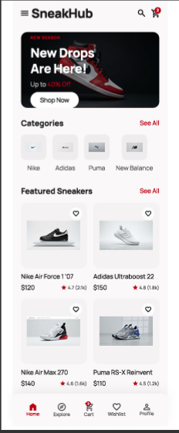
The Home Screen serves as the main dashboard of the application.
It includes:
- SneakHub logo
- Search icon
- Shopping cart icon
- Promotional banner
- Brand categories
- Featured sneakers
- Bottom navigation menu
The screen allows users to quickly discover featured products and navigate to other parts of the application

Screen 2 : Product Details Screen

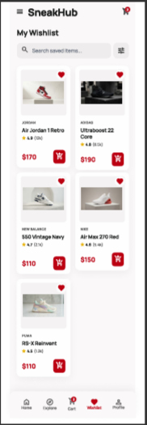
The Product Details Screen provides complete information about a selected sneaker.
It contains:
- Large product image
- Product name
- Price
- Product description
- Ratings and reviews
- Shoe size selection
- Color selection
- Quantity selector
- Add to Cart button
This screen enables users to customize their purchase before adding the product to the cart.

Screen 3 : Shopping Cart Screen

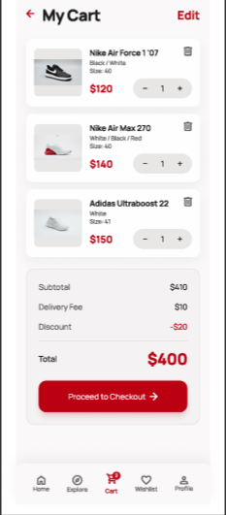
The Shopping Cart Screen displays all selected products before checkout.
Features include:
- Product list
- Product images
- Quantity controls
- Remove item option
- Price summary
- Delivery fee
- Discount
- Total amount
- Proceed to Checkout button
The cart provides users with complete visibility of their purchase before payment.

Screen 4 : Wishlist Screen

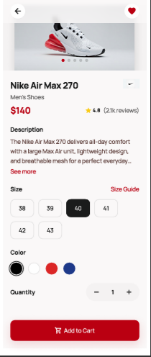
The Wishlist allows users to save favorite sneakers for future purchase.
Features include:
- Saved sneaker list
- Product image
- Product price
- Favorite indicator
- Quick access to product details
- Option to move items to the shopping cart
The Wishlist improves user convenience by allowing customers to keep track of products they are interested in.

Screen 5 : Profile Screen

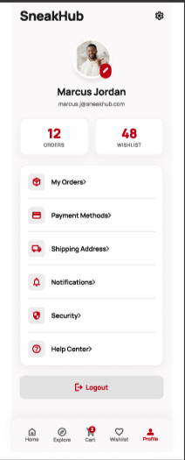
The Profile Screen enables users to manage their personal account.
It contains:
- Profile picture
- User information
- Edit Profile option
- Order History
- Payment Methods
- Address Management
- Settings
- Logout button
This screen centralizes all user account management functions.

Human Computer Interaction Principles Applied
Several HCI principles were incorporated into the SneakHub interface.

Consistency
All screens use the same colors, fonts, icons, spacing, and button styles, creating a unified experience.

Visibility
Important actions such as Add to Cart and Checkout are prominently displayed using bold red buttons.

Feedback
Interactive elements provide immediate visual feedback, helping users understand that their actions have been recognized.

Simplicity
The interface avoids unnecessary clutter, ensuring users can focus on products and primary actions.

Learnability
The navigation layout follows common mobile shopping conventions, making it easy for first-time users to understand.

Accessibility
Large touch targets, readable typography, and strong color contrast improve usability for a wide range of users.

User Experience (UX) Considerations
The interface was designed with user experience as a priority.
Key considerations include:
- Easy navigation through the bottom navigation bar
- Clear product categorization
- High-quality product images
- Minimal user input during shopping
- Large action buttons
- Consistent spacing and alignment
- Fast access to important shopping features
These design choices reduce user effort and create a smooth shopping experience.

Challenges Encountered
Several challenges were faced during the design process:
- Selecting a consistent color palette
- Aligning multiple UI components accurately
- Maintaining consistency across all five screens
- Choosing appropriate typography
- Organizing reusable components in Figma
- Ensuring sufficient spacing and balance throughout the interface
These challenges were addressed through repeated iterations and the use of Figma's Auto Layout and component system.

Conclusion
The SneakHub mobile application successfully demonstrates the application of Human Computer Interaction principles in designing a modern sneaker shopping experience.
The five screen prototype provides users with an intuitive interface for browsing products, viewing detailed information, managing shopping carts, saving favorite items, and managing personal accounts. The use of consistent design elements, reusable components, and effective navigation contributes to a seamless and enjoyable user experience.
Overall, the project meets the objectives of the assignment by delivering a professional, visually appealing, and user-centered high-fidelity mobile application prototype.

References (APA 7th Edition)
Cooper, A., Reimann, R., Cronin, D., & Noessel, C. (2014). About Face: The Essentials of Interaction Design (4th ed.). Wiley.
Krug, S. (2014). Don't Make Me Think, Revisited: A Common Sense Approach to Web Usability. New Riders.
Norman, D. A. (2013). The Design of Everyday Things (Revised ed.). Basic Books.
Nielsen, J. (1994). Usability Engineering. Morgan Kaufmann.
Shneiderman, B., Plaisant, C., Cohen, M., Jacobs, S., Elmqvist, N., & Diakopoulos, N. (2016). Designing the User Interface: Strategies for Effective Human–Computer Interaction (6th ed.). Pearson.

- Figma Prototype Link : https://www.figma.com/design/jPF0lK344eWfuhCEq8JNJe/SneakHub-UI-Assignment?node-id=0-1&t=3wmvrIbuEJb1KNoB-1

